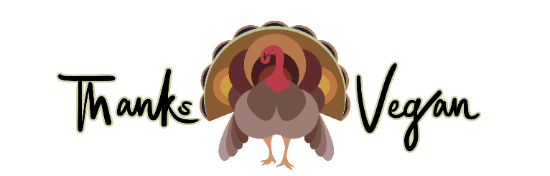

ThanksVegan Feast

People who come to this event care deeply about the food they eat and there are those who are also sensitive or allergic to certain food ingredients. We, the volunteers of Voices for Animals, have no way to guarantee what ingredients are in the potluck dishes that attendees bring or how the food was prepared. In order to allow attendees to choose what food ingredients are appropriate for them and understand the potential risks for participating in ThanksVegan Feast, please do the following: 1. Fill out ingredients card to display with your prepared food donation (at Registration) and 2. Please sign the following three Agreements:

Agreement 1: Hold Harmless Waiver and Food Content Agreement

I understand that this is a community potluck event and by my participation agree to hold harmless Florida Voices for Animals and its volunteers for the quality or content of any of the food, whether it is homemade or purchased.

I have honestly completed an ingredients card that accompanies any potluck dish that I may have brought to share with the community and assert that it does not contain any animal or insect ingredients or byproducts (including meat, dairy, eggs, fish or honey).

_______________________ _______________________
Print Your Name Sign Your Name

Agreement 2: Photographs and Video Agreement

I understand that this is a community potluck event and that the organizers of the event are going to be taking photographs and video of the event and its participants to help publicize the event and help the world wide community understand the benefits of veganism and welfare of animals. In addition, an outside media group will be taking photographs and video of their staff and some attendees may be included as a result of their proximity to their staff.

By signing this Agreement, you are giving permission to be photographed, filmed and that your likeness may appear on a public website or movie and that you will not be compensated in any way for the use of those photographs or videos either today or in the future.

_______________________ _______________________
Print Your Name Sign Your Name

Agreement 3: Conduct Agreement

I understand that while on the property of the Unitarian Universalist Church attending ThanksVegan, I must act responsibly and courteously to others and that I may be asked to leave the premises at any time by an Organizer Lead volunteer should I fail to do so.

_______________________ _______________________
Print Your Name Sign Your Name

